Infrastructure as Code (IaC)

Infrastructure as Code (IaC) is the practice of creating, configuring, and managing infrastructure using machine-readable configuration files instead of manually configuring infrastructure through a web console.

Instead of manually creating servers, networks, databases, etc., you write code that describes what infrastructure you want, and a tool creates it for you.

Github repo: https://github.com/iampratik11/terraform_exercise.git

Install Terraform

Install prerequisites
sudo apt-get install -y gnupg software-properties-common
HashiCorp documents these packages as prerequisites for the Ubuntu/Debian installation.

Add HashiCorp's GPG key
Run:
wget -O- https://apt.releases.hashicorp.com/gpg | \
gpg --dearmor | \
sudo tee /usr/share/keyrings/hashicorp-archive-keyring.gpg > /dev/null

Add the HashiCorp repository
Run:
echo "deb [arch=$(dpkg --print-architecture) signed-by=/usr/share/keyrings/hashicorp-archive-keyring.gpg] https://apt.releases.hashicorp.com $(grep -oP '(?<=UBUNTU_CODENAME=).*' /etc/os-release || lsb_release -cs) main" | \
sudo tee /etc/apt/sources.list.d/hashicorp.list
This configures APT to use HashiCorp's official repository.
Update APT
sudo apt update

Install Terraform
sudo apt-get install terraform

Verify
Run:
terraform version
Create infrastructure
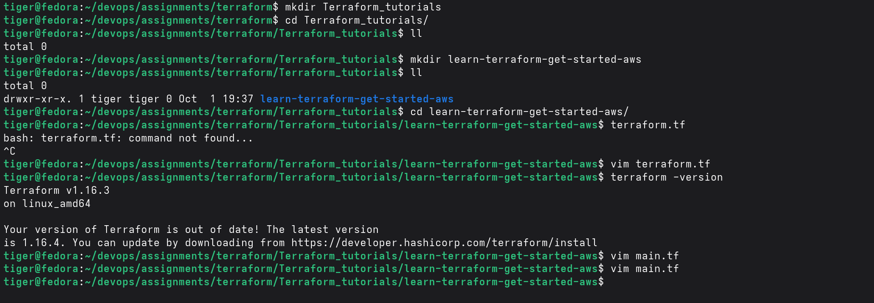

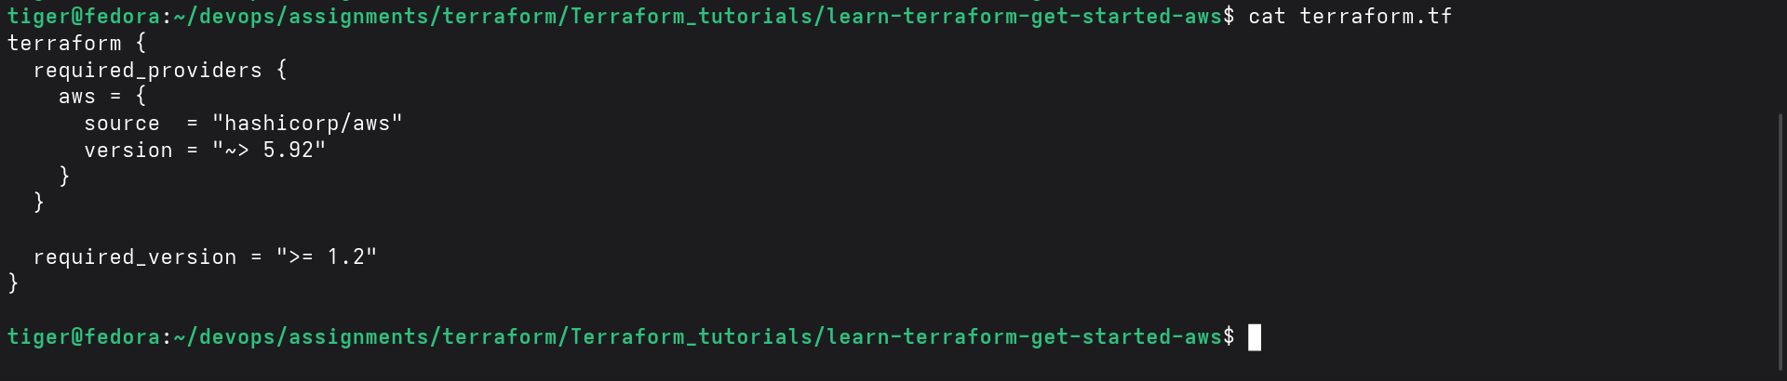

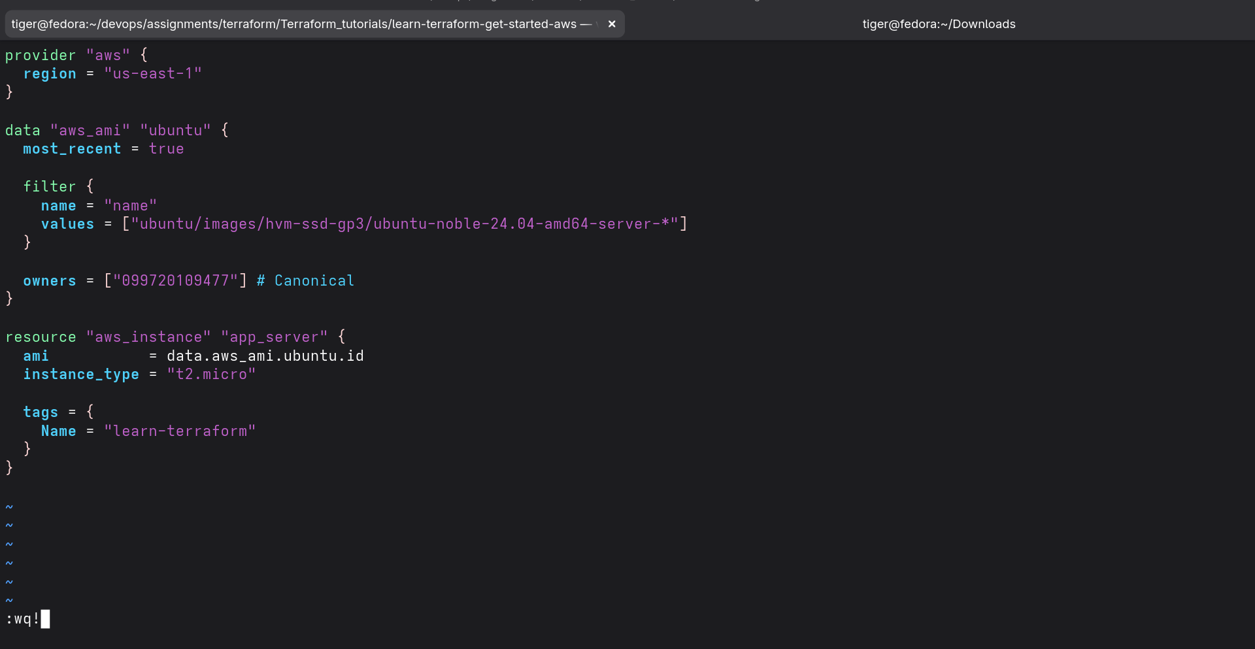

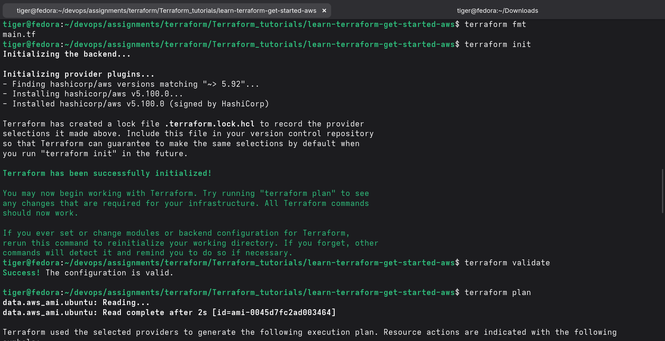

Terraform apply
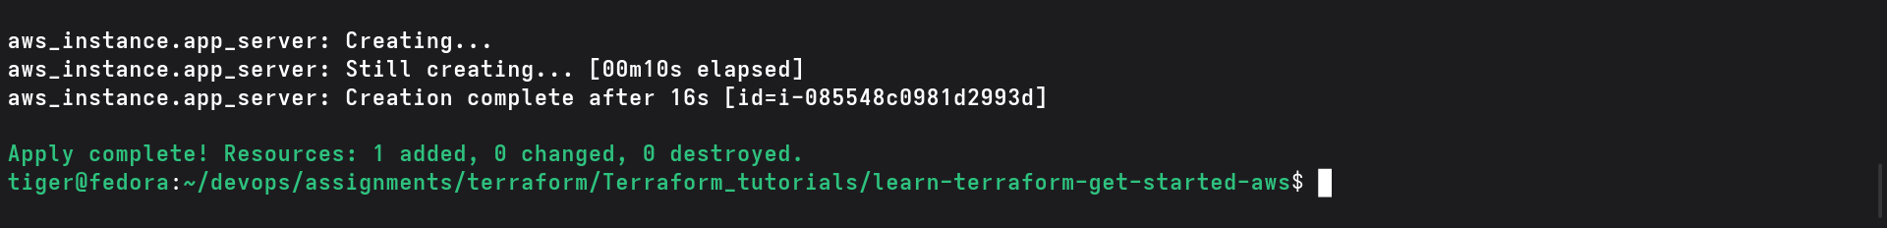

Output
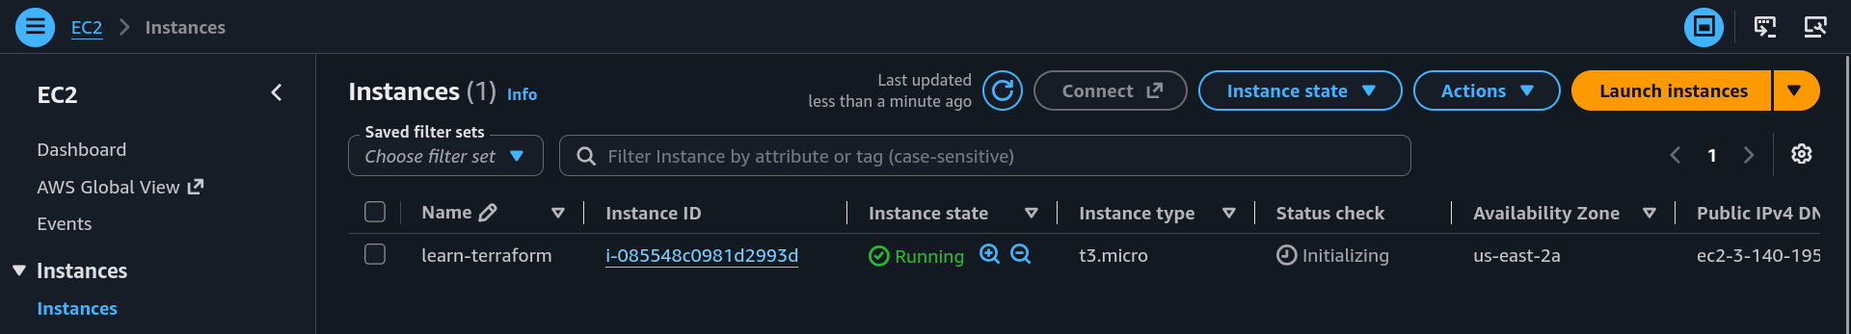

Terraform destroy
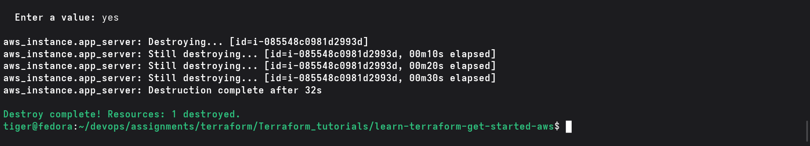

Manage infrastructure

Define variable file
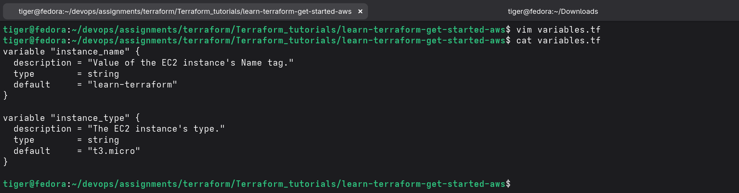

Update the instance configuration
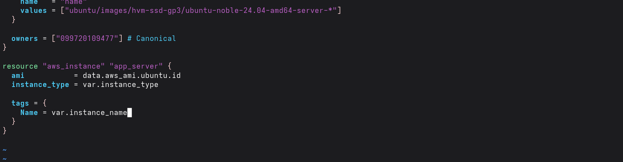

Create output file
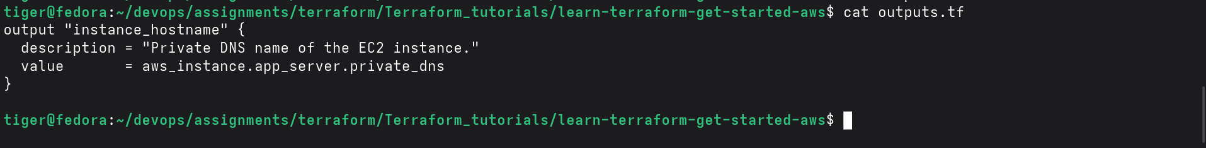

Change instance type
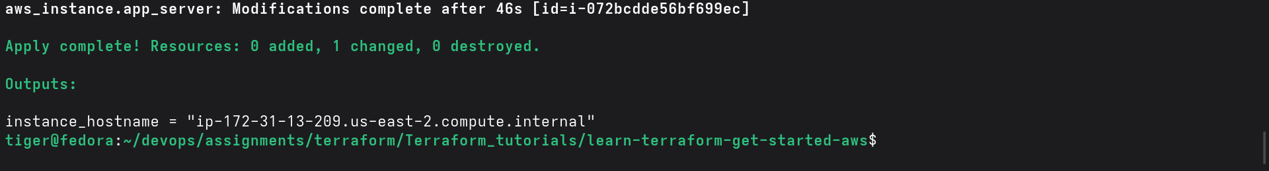

Destroy workspace

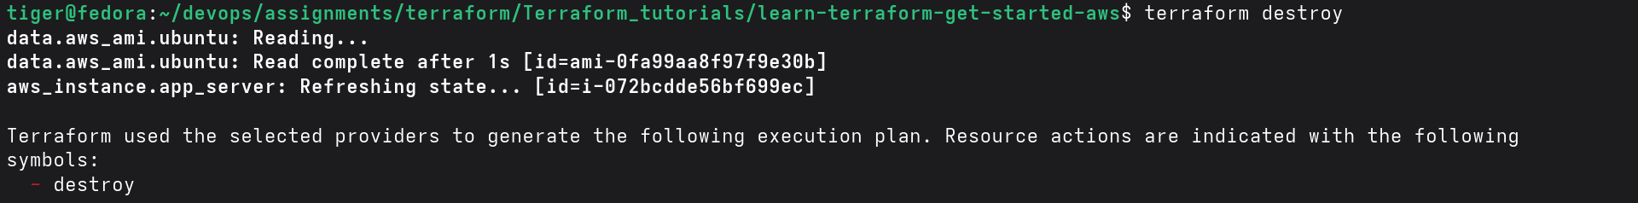

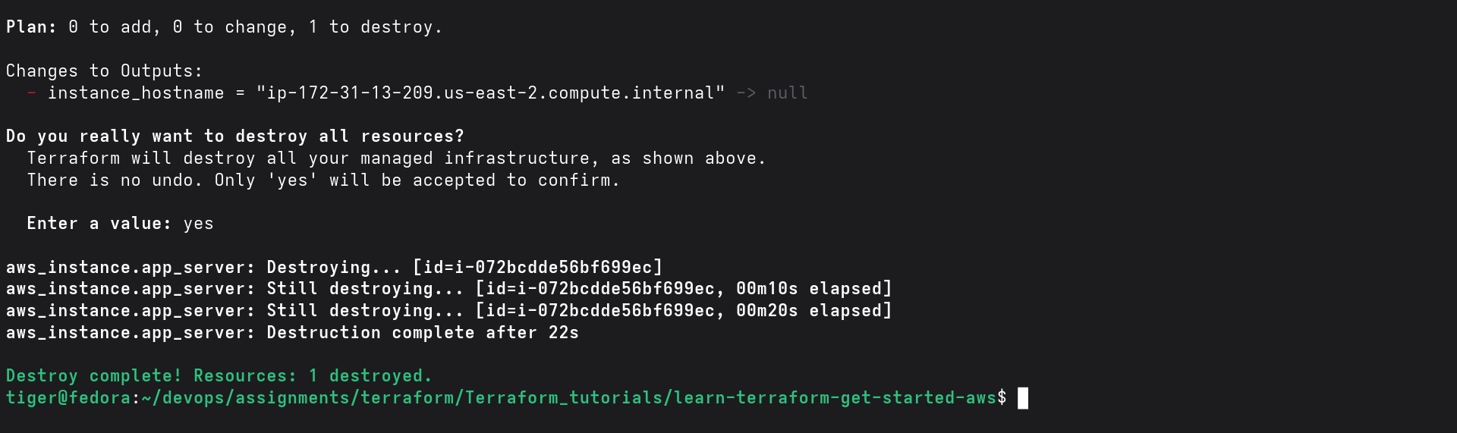

Store Remote State (S3 Backend)

